**‘WST’ TWIN WIRE ARC SPRAY SYSTEM**

**MODEL: WST-8830/600-AR**

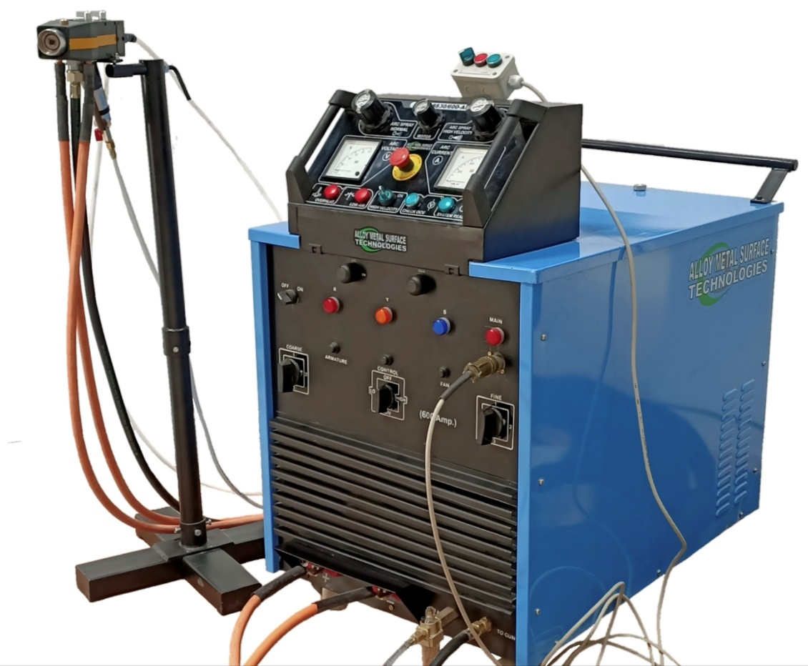

Offered twin wire arc spray system; Model : WST-8830/600-AR combines typical features of the modern arc spray technology. The offered system operates on Pull Type principle wherein the wire is pulled by the electric arc gun roller which is driven by a pneumatic air motor.

The offered arc spray system is suitable for any type of pure metallic wire, alloyed wire and cored wire of diameter 1.6mm to 2.3mm (Aluminium) and 2.5mm Zinc. The most common application of WST-8830/600-AR system is ALL TYPES OF SITE COATING WORK.

The operation of the wire feeding arrangement is achieved by a pneumatic air motor which has On/OFF lever and the ampere can be changed by a ball valve mounted at the inlet supply of air motor for uniform and evenly wire feed rate for the consistent & uninterrupted arc spray process.

The offered arc spray system is designed to use at low voltage as well as high level for major coating application while maintain the same arc ampere for consistent spray process. The system is designed for low cost operation and highly reliable in operation with low consumption of spare parts.

**WORKING PRINCIPLE:**

The model WST-8830/600-AR arc spray Gun utilizes electrical D.C current to melt the metallic wire at suitable arc voltage required for the respective metal property and uses compressed air high velocity to finally atomize the molten metal particles into an extremely fine spray pattern on to substrate to be metalized. During arc spray metalizing process, an electric arc is generated & maintained consistently at the contact point of two metal wires.

The wires are continuously fed from the contact tip and nozzle positioner to the mating position to form arc and due to high voltage between two wires, arc form which melt the wire. At the same time compressed air is directed along the arc spray process to atomize the particles which it comes out from the air cap to have narrow/wide spray pattern as per the type of the cap selected for the suitable coating application.

|  |  |
| --- | --- |
| **Power Source** |  |
| Input Required Voltage | 415 V max. |
| Input Main Supply | 3 Phase, 50 Hz |
| Maximum Power Capacity | 25 kW |
| OCV | 19 – 52 V |
| Current | 600 Amps at 75% duty cycle.  450 Amps at 100% duty cycle. |
| **Fuses** |  |
| Control | 05 Amps |
| **Max. Ambient Temp. to which the ratings apply** | 45° C |
|  |  |
| **Compressed Air Requirement** | 70 CFM (FAD) at 90 PSIG air pressure |
|  |  |
| **Wire Feed Mechanism** | By Pneumatic Air Motor fitted on the gun |
|  |  |
| **Complete machine weight** | Approx. 290 Kg. |

The WST-8830/600-AR Arc spray System consists of the following items:

1. Arc Spray Gun; Model : 8830-AR with Interconnecting Hoses & Cables
2. Power Source with Control Console; 8830/600-AR
3. Wire Reel stand & Gun Mounting Stand
4. Spare Parts for Commissioning & Testing

**ARC SPRAY GUN; MODEL : 8830-AR WITH INTERCONNECTING HOSES & CABLES**

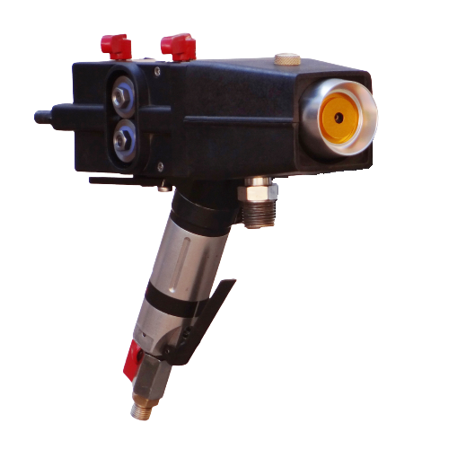

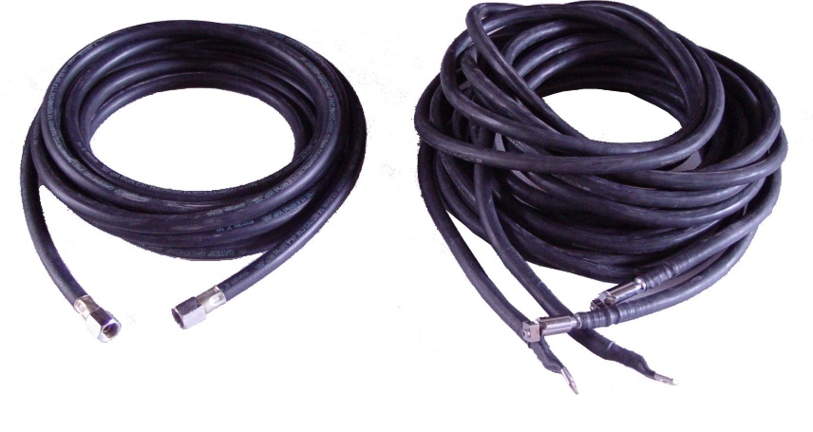

Offered Arc Spray Gun 8830-AR is light weight gun with user friendly operation to use. The gun is sturdy in design and offers low breakdown maintenance. It has powerful pneumatic motor to feed spray wire at constant speed. Easy to handle by the operator for maneuvering the gun for coating.

The flexible hoses package has a standard length of 5 meters though this length can be designed to meet your requirements. The hose package consists of two current cables on an atomizing air hose. The hose is designed to be flexible to simplify the automation of the system. The cable has a standard length of 5 Mtr.

**POWER SOURCE WITH INBUILT CONTROL PANEL; MODEL : 8830/600-AR**

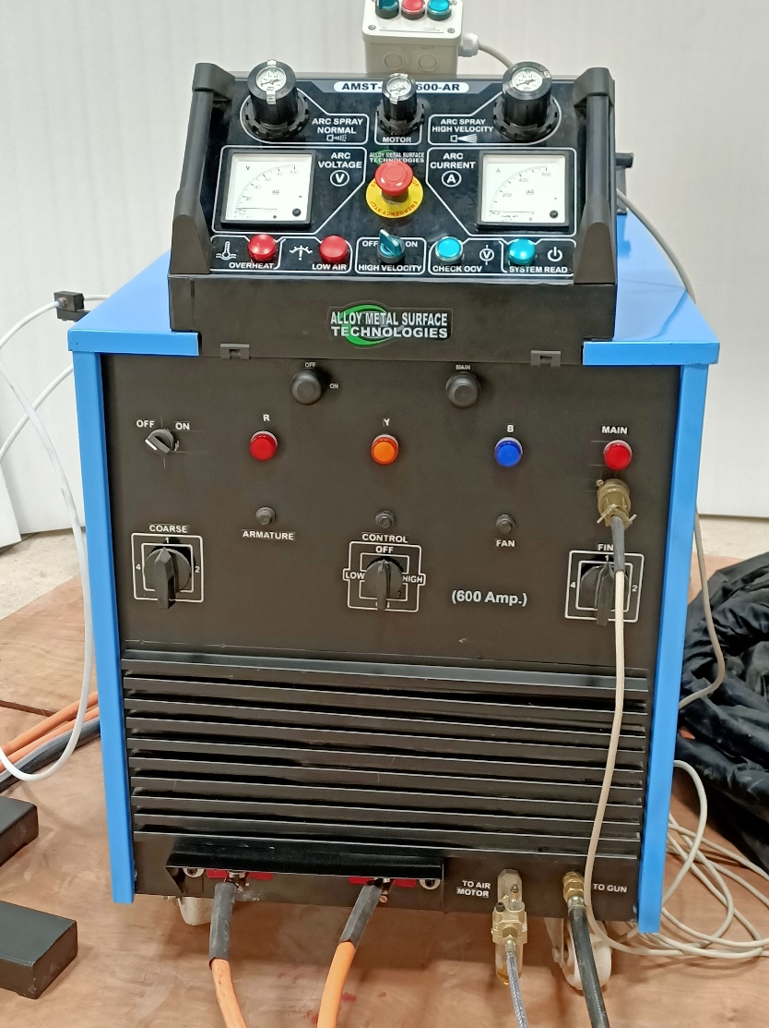

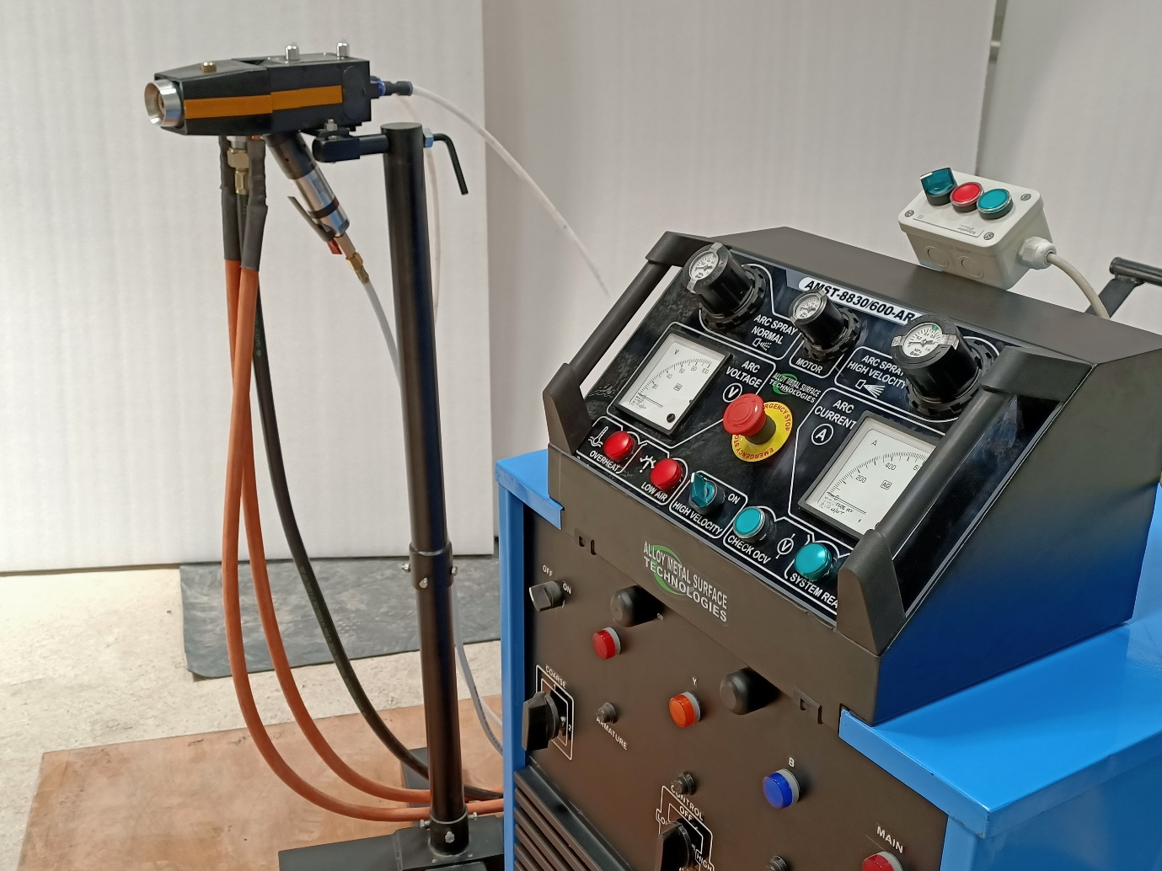

The offered Power source is designed to meet the requirement of electric arc technology of DC voltage with integrated control and ergonomic as well as user friendly control panel. The start & stop of the arc is achieved by pressing lever of air motor thus offers dead-man handle for safe working operation stopping the gun, if dropped down.

The offered power source is a diode based design to operate in harsh environment and meets the requirement of spraying all kinds of metallic, alloyed and cored wires. This control circuit has a response time adjusted to the arc spraying process to ensure a stable arc between the melting wire contact point. The Power Supply is especially developed for arc spraying with integrated control and ergonomic operator console.

The WST UNIT is equipped with an electronic control circuit adapted to arc spraying of various materials. This control circuit has a response time adjusted to the arc spraying process to ensure a stable arc between the melting electrodes.

The effects on the process are tremendous. The control reduces the voltage variations and allows a uniform coating process at a lower voltage.

The melting-off energy in the arc is more uniform than in conventional arc spraying power sources. This also applies to the droplet size and heat content of the individual particles. Overheating of the spray particles is reduced; burn-off rates and oxidation are minimized. Together, these factors result in an improved coating quality.

High Velocity mode is available with this model which means better deposit efficiency, Better plasma like coating properties & fine and focused spray.

The electronic power supply allows working at maximum capacity at a duty cycle of 100%.

**SEPARATE WIRE SPOOL STAND & GUN MOUNTING STAND – STANDARD SUPPLY**

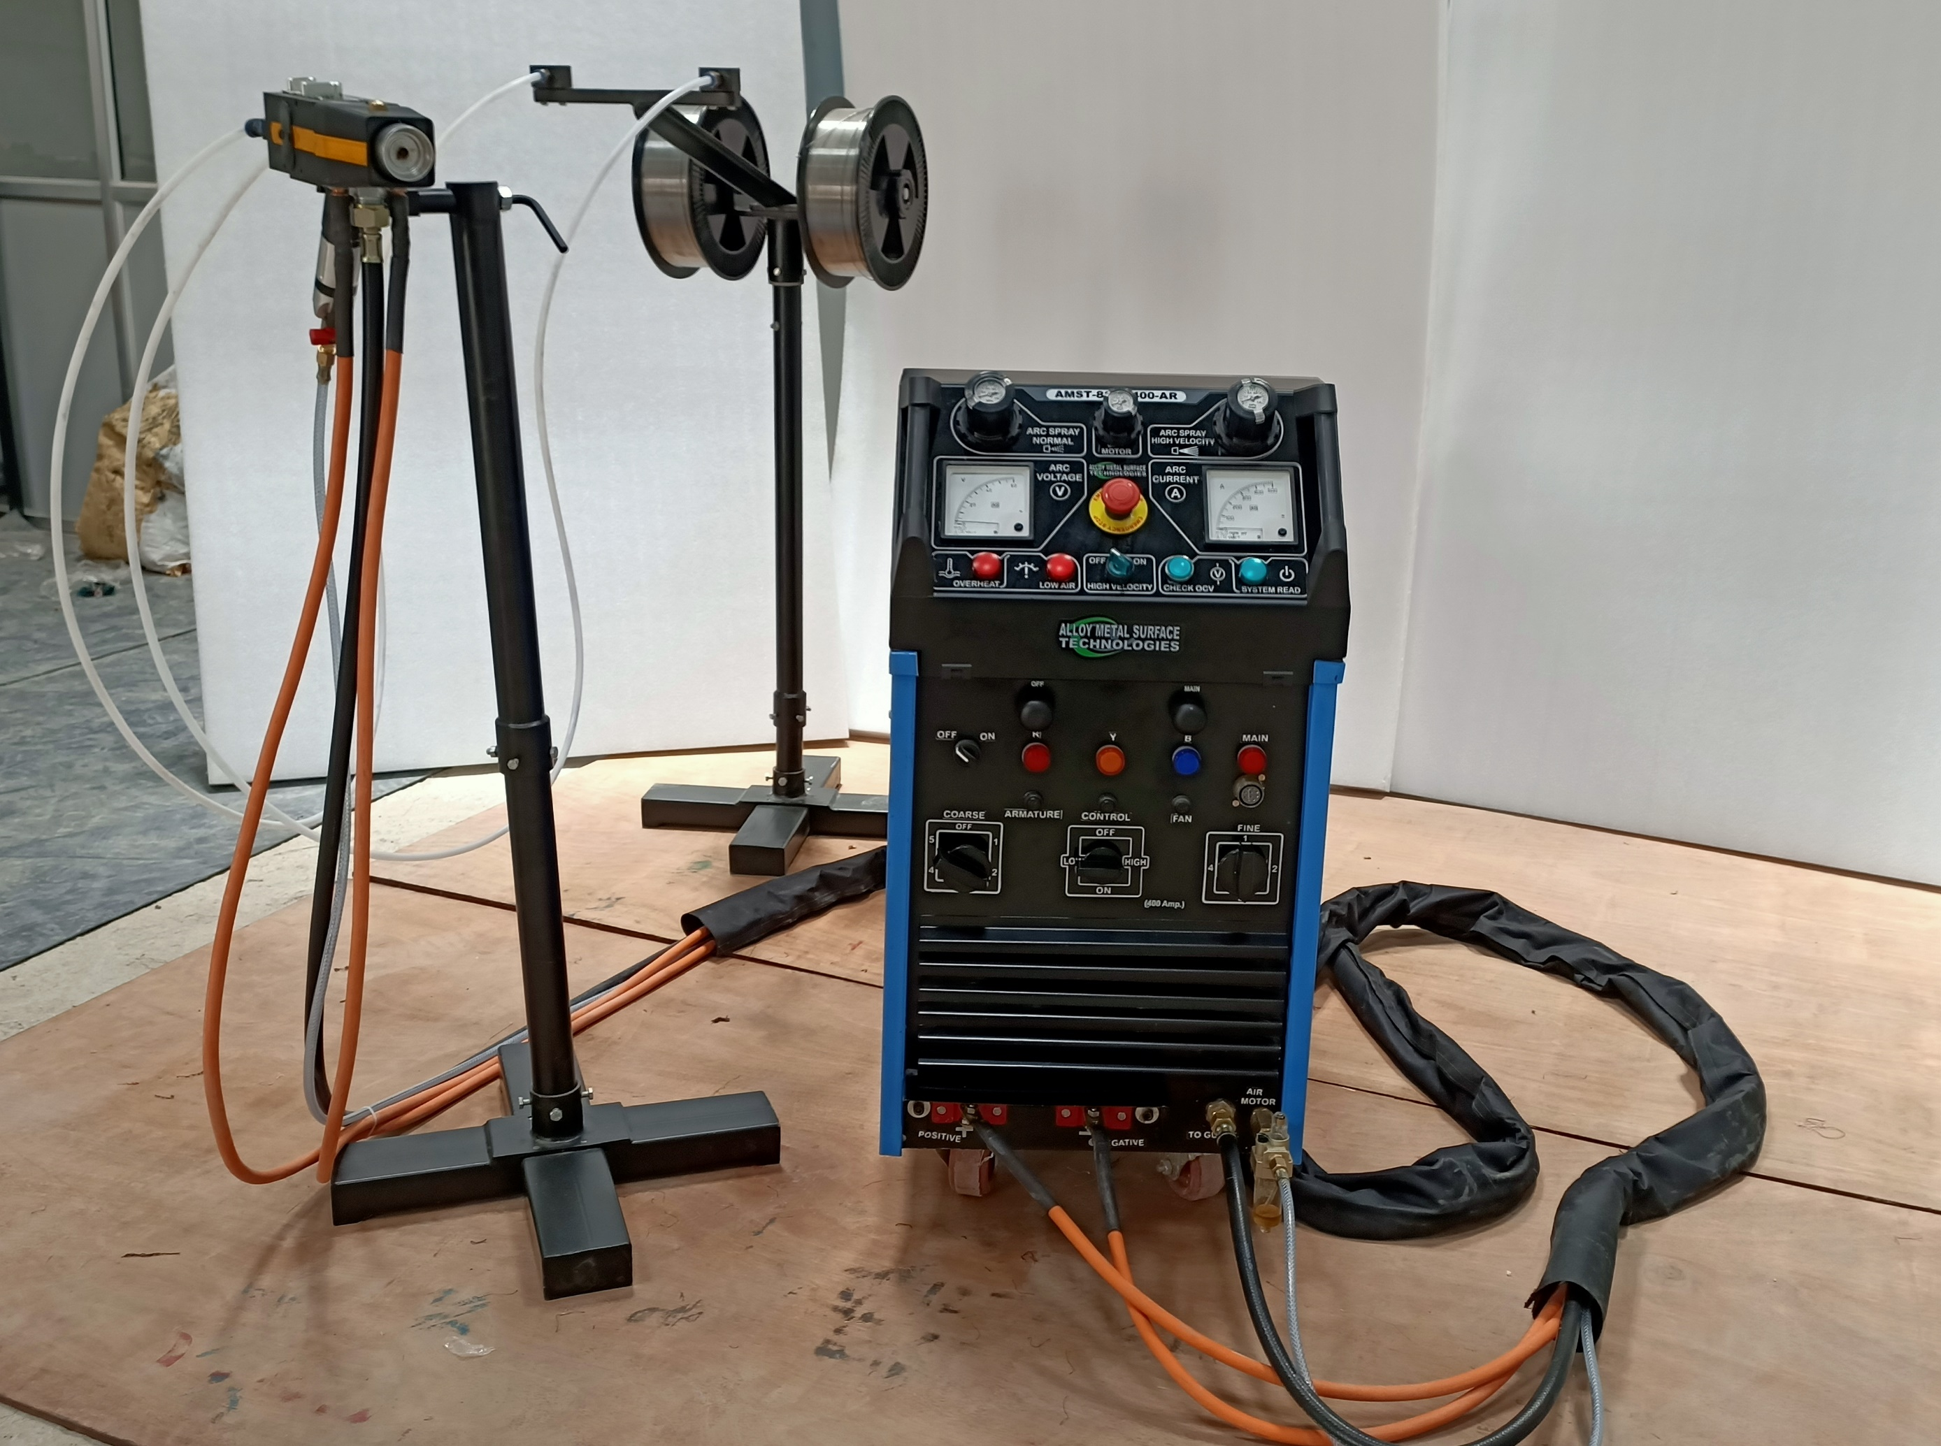

Arc spray system is offered with wire reel stand for holding the plastic wire spools and allows easy & smooth rotation of spools while arc spray coating is going on, thereby offering consistent and un-interrupted wire discharge from the spools. On the wire reel stand a push-in connector is offered to fix the Teflon tubes in the connector.

The wires free from any bends or kinks are dispensed from the spools through wire feed tubes and are made to pass through wire guides in the spray gun.

The main feature of WST Wire Spool Stand & Gun Mount Standis PORTABLE & MOVEABLE so it can be moved near to job, away from power source.

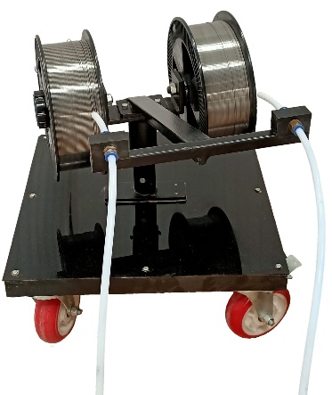**PORTABLE WIRE SPOOL TROLLEY – OPTIONAL SUPPLY**

The two wires, which serve as the two electrodes for the arc, are supplied from two insulated wire spools, mounted on a portable trolley, as per customer convenience. The wires free from any bends or kinks are dispensed from the spools through wire feed tubes and are made to pass through wire guides in the spray gun.

**BUYER’S SCOPE OF ITEMS/WORK/ACCESSORIES AT NO COST TO SELLER:**

1. Dry and oil free compressed air 70 CFM @ 90 psig upto gun control panel
2. A.C. Electrical Supply 15kW at 3Ø & 4 wire, 415 V / 50 Hz, 1 Neutral and 1 Ground upto control panel.
3. All wiring from customer’s main power point to WST machine’s control panel and earthing wherever required.
4. Dust disposal arrangement
5. Separate earthing for control panel
6. Coating wire at site.